HL7 Server Control Panel Guide

Database Configuration

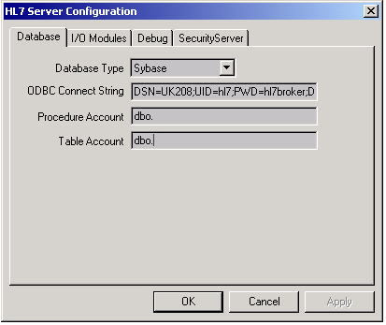

Database Type
Choices are: Sybase and Oracle

ODBC Connect String
A standard ODBC connect string which consists of the following entries:
DSN=data source name data source name must match the name used in the ODBC System DSN entry.
UID=user id The username that HL7 Server will use when connecting to the database.
PWD=password The password that HL7 Server will use when connecting to the database.
DB=database name The name of the database that HL7 Server will connect to

Example:
DSN=SYBASE;UID=sa;PWD=heythere;DB=mcms_pacs

Procedure Account and Table Account
This is the text that is prefixed to all table names and stored procedure names. For Sybase systems both values will always be “dbo.” (including the dot). For Oracle systems, this is the name of the database owner.
Adding New Modules

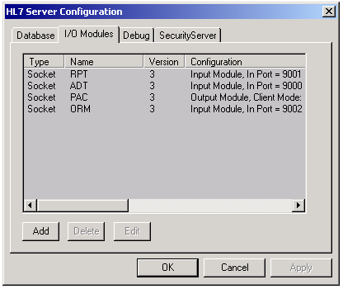

1 – Press Add

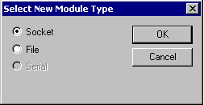

2 – Select Socket or File

Socket Modules

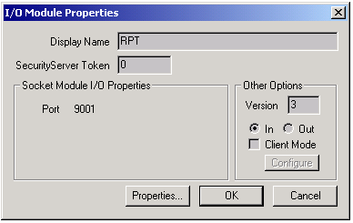

Display Name The name must match the name given in the “process codes” file on the UNIX system. This file is used by the process monitor to show application activity.

Port This is the Socket port number that HL7 Server will expect to receive data. This port number is configured by pressing the Properties… button. This should be set to zero when Client Mode is specified.

Version When the entry is non-zero, the value must match the corresponding version column in the HL7_xxx tables in the database. When this value is zero, the version will be derived from the MSH record or each message received.

In/Out Input modules are the “normal” HL7 modules. They receive data from another system, update the database, and send a response message. Output modules create messages, send them to another system, and receive response messages.

Client Mode

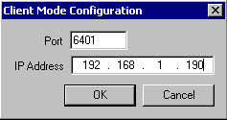

When in client mode, HL7 Server periodically connects to the port and IP address specified in the Client Mode Configuration dialog, to request HL7 messages. When the module is also an output module, this is the port and IP address used to send output messages.

File Modules

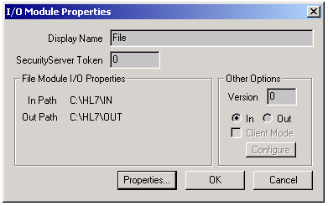

Display Name The name must match the name given in the “process codes” file on the UNIX system. This file is used by the process monitor to show application activity.

In/Out Path These are the paths where HL7 Server will receive data and write status messages. These paths are configured by pressing the Properties… button.

Version When the entry is non-zero, the value must match the corresponding version column in the HL7_xxx tables in the database. When this value is zero, the version will be derived from the MSH record or each message received.

Debug

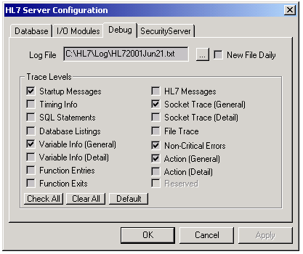

Log File Specifies the full pathname of the log file. When “new file daily” is selected, this is the directory where log files will be created.

New File Daily Creates a new log file daily with the filename format of HL7yyyymmmdd.txt where yyyy = the year, mmm = the month, dd = the day.

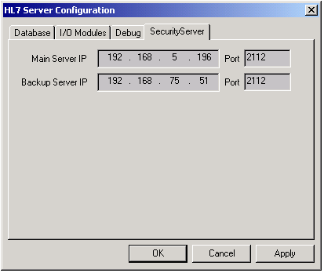

This panel has no effect in the current version.

